Emotion Correlation Mining Through Deep Learning Models on Natural Language Text

SNEHA.B, R.SWARNALASHMI , ZULAIHA FATHIMA.V.I
Assistant Professor –Dr.T.JACKULIN,M.E.,Ph.D.,Assistant Professor(Gr-1)
Department of Computer science Engineering, Panimalar Engineering College, Anna University, Chennai, India

ABSTRACT
Emotion analysis from text is one of the hot topics in modern natural language understanding. Embedding and attention mechanisms help a lot with emotion recognition in deep learning methods. Emotion analysis has been attracting researcher’s attention. Most previous works in the artificial-intelligencefield focus on recognizing emotion rather than mining the reason why emotions are not or wrongly recognized. The CNN and Collaborative algorithm is used here. The given input data are per-processed and then the classification is done and final results will be integrated such as the given number of title, emotion, hashtags, and commands will be collected and separately given as the output. The correlation among emotions contributes to the failure of emotion recognition. To mine emotion correlation from emotion recognition through text, three kinds of features and two deep neural-network models are presented. The emotion confusion law is extracted through an orthogonal basis. Emotion analysis, as an important traditional branch of knowledge mining, is categorized into three levels, namely: word level, sentence level, and
.

document level.
Keywords - Emotion analysis ,artificial-intelligence , deep neural network, natural language processing , emotion recognition

- INTRODUCTION

Most previous works in the artificial-intelligence field focus on recognizing emotion rather than mining the reason why emotions are not or wrongly recognized. The correlation among emotions contributes to the failure of emotion recognition. In this article, we try to fill the gap between emotion recognition and emotion correlation mining through natural language text from Web news. The correlation among emotions, expressed as the confusion and evolution of emotion, is primarily caused by human emotion cognitive bias. To mine emotion correlation from emotion recognition through text, three kinds of features and two deep neural-network models are presented. The emotion confusion law is extracted through an orthogonal basis. The emotion evolution law is evaluated from three perspectives: one-step shift, limited-step shifts, and shortest path transfer. The method is validated using three datasets: 1) the titles2) the bodies and 3) the comments of news articles, covering both objective and subjective texts in varying lengths (long and short). The experimental results show that in subjective comments, emotions are easily mistaken as anger. Comments tend to arouse emotion circulations of love–anger and sadness–anger

- SYSTEM ARCHITECTURE
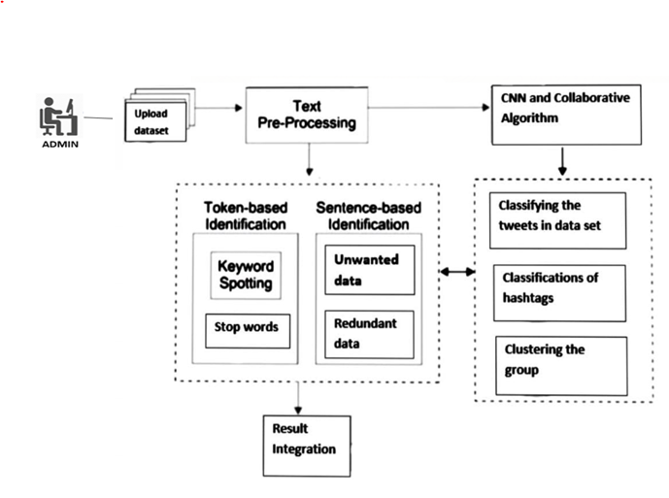
Initially upload the data set, once the data set is uploaded text per-processing is done. The algorithm is used here are CNN and COLLABORATIVE algorithm.

Token based Classification and Sentence based Classification:
Here key word spotting is done,Keyword spotting is also defined as a separate, but related, problem in the context of document image processing. In document image processing, keyword spotting is the problem of finding all instances of a query word that exist in a scanned document image, without fully recognizing it.stop words are removed, and unwanted data and redundant data also removed.

Classifying the tweets in data set:
Publicly available tweets are fetched and classified and content expressed in tweets are extracted and normalized. This research uses domain-specific seed list to classify tweets. Semantic and syntactic analysis on tweets is performed to minimize information loss during the process of tweets classification.

Classification of hashtag:
Hashtags are classified into three categories, a topic which is closely connected to a certain hashtag, sentiment hashtags which express subjective opinions and sentiment-topic hashtags which indicate a certain target word and the sentiment words.

Clustering into groups:
Clustering is the task of dividing the population or data points into a number of groups such that data points in the same groups are more similar to other data points in the same group than those in other groups. In simple words, the aim is to segregate groups with similar traits and assign them into clusters.

Using the algorithm the classifying the tweets in data set, classifications of hashtags and clustering the groups all are done and finally Result is integrated.

- MODULE DESCRIPTION

A precise statement of the effects that a software module is required to achieve. It can be employed both by the implementer of the module, since it gives a definitive statement of the requirements that are imposed on the module, and by users of the module, since it gives a precise statement of what the module provides. A good module specification makes no commitment as to how the module's effects are achieved.In this project there is only one module , it is admin module.
Firstly we have to register into our system and once the registration process is done, we can login into the system .As a security measure only authorized Admin are able to access our system. After the registration and login process are successfully completed. The collected or related data set for which the specific output needed has to be uploaded into the system.And then data processing is done. Data preprocessing is a data mining technique that involves transforming raw data into an understandable format where all the process such as stop word removal, stemming, tokenization is also done to remove the unwanted data . Classification of hashtag takes place using collaborative algorithm and CNN algorithm . Hashtags are classified into three categories, a topic which is closely connected to a certain hashtag, sentiment hashtags which express subjective opinions and sentiment-topic hashtags which indicate a certain target word and the sentiment words.And then Feature extraction is done to predict the tweets keyword in group based on the input data and the user name provided .Group recommendation is the process which helps to calculate the betweens value which means to find out the user who is in more thaan in one group.This helps in finding out the fake tweets or information in our input data .Then the classification of tweets into groups is done where the collaborative algorithm is used to remove the redundant data and with the help of CNN algorithm clustering is done, Clustering is the task of dividing the population or data sets into a number of groups such that data points in the same groups are more similar to other data points in the same group than those in other groups. In simple words, the aim is to segregate groups with similar traits and assign them into clusters.The most important step is that the performance analysis is done to calculate the algorithm accuracy by using confusion matrix .Finally, the result is integreated in graph format based on the number of tweets in each group.

  - ALGORITHM

CNN ALGORITHM:
Convolutional Neural Network (ConvNet/CNN) is a Deep Learning algorithm which can take in an input image, assign importance to various aspects/objects in the image and be able to differentiate onefrom the other. The pre-processing required in a ConvNet is much lower as compared to other classification algorithms. While in primitive methods filters are hand-engineered, with enough training, ConvNets have the ability to learn these filters/characteristics.

COLLABORATIVE ALGORITHM:
Collaborative filtering is a technique that can filter out items that a user might like on the basis of reactions by similar users.It works by searching a large group of people and finding a smaller set of users with tastes similar to a particular user. It looks at the items they like and combines them to create a ranked list of suggestion

- COMPARISON OF EXISTING AND PROPOSED SYSTEM

In existing system the use of social networks for political participation and demonstrations is anew and evolving phenomenon occurring in events. Most previous works in the artificial-intelligence field focus on recognizing emotion rather than mining the reason why emotions are not or wrongly recognized. The correlation among emotions contributes to the failure of emotion recognition. The latest is a research domain that is catching the attention of the academic community, and refers to the misuse of hash tags for a different purpose that the one that was originally set, generating confusion to users interested in the topic associated to the original hash tag.
Whereas in proposed system to mine emotion correlation from emotion recognition through text, three kinds of features and two deep neural-network models are presented. The emotion confusion law is extracted through an orthogonal basis. The emotion evolution law is evaluated from three perspectives: one-step shift, limited-step shifts, and shortest path transfer. The method is validated using three datasets: covering both objective and subjective texts in varying lengths (long and short). The experimental results show that in subjective comments, emotions are easily mistaken as anger. Comments tend to arouse emotion circulations of love–anger and sadness–anger. The CNN and Collaborative algorithm is used here. The given input data are tweets per-processed and then the classification is done and final results will be integrated such as the given number of title, emotion, hash tags, and commands will be collected and separately given as the output.

4.1 COMPAIRSION GRAPH:

EXISTING SYSTEM GRAPH:

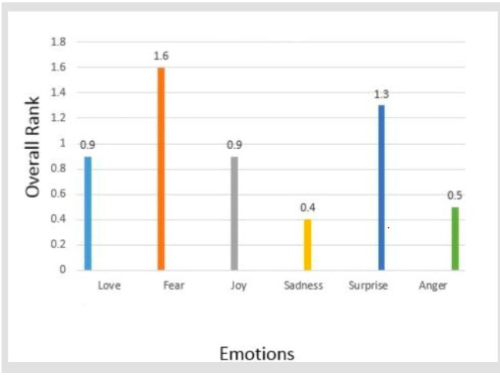

PROPOSED SYSTEM GRAPH:

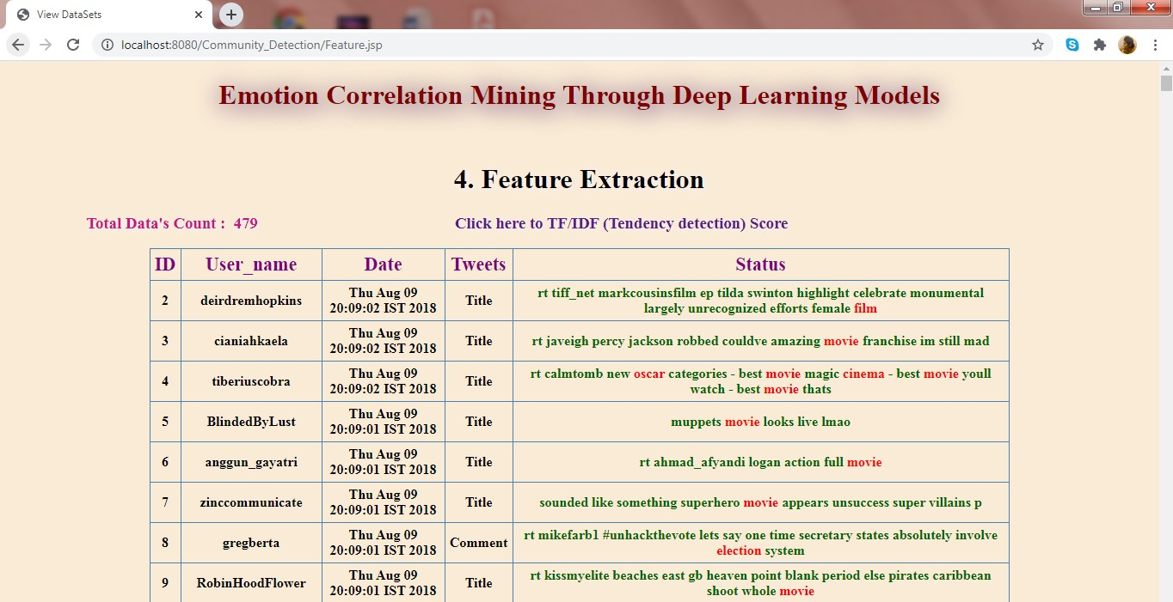
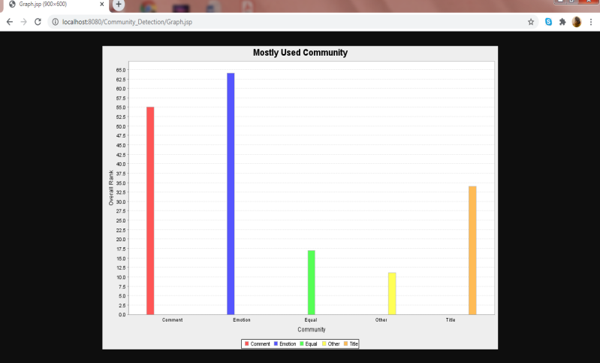

The earlier existing system coordinates only the twitter sentiment analysis. Involves classifying opinions in text into categories like "positive" or "negative" or "neutral". In our proposed system coordinates with deep learning methods finds out and categoriestge mostly used communities such are title, emotion, comment etc.

SCREENSHOTS:

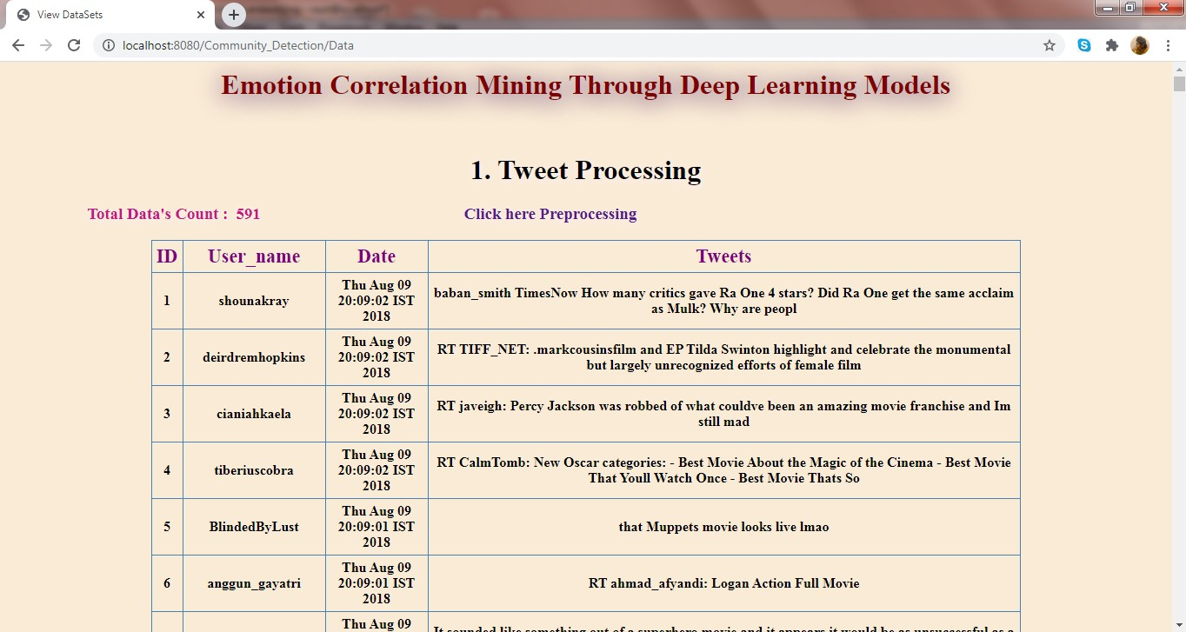
Tweet processing
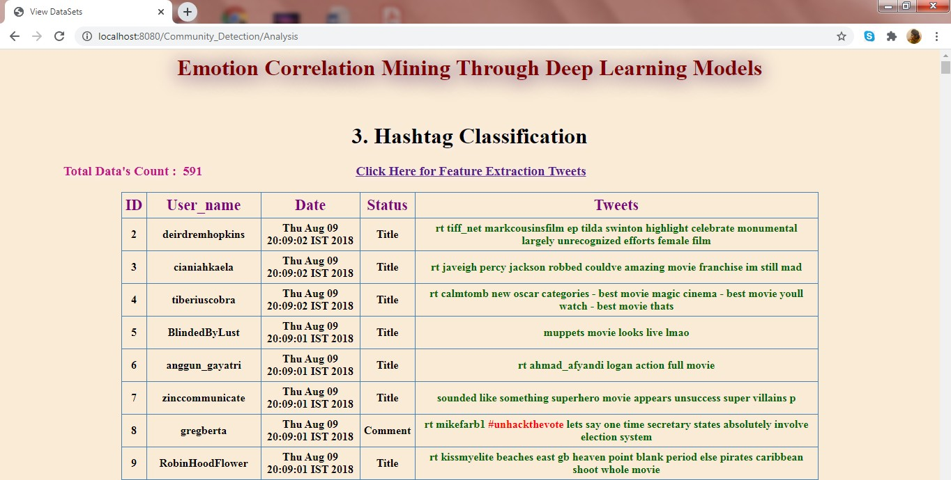
Hashtag Classification
Feature Extraction

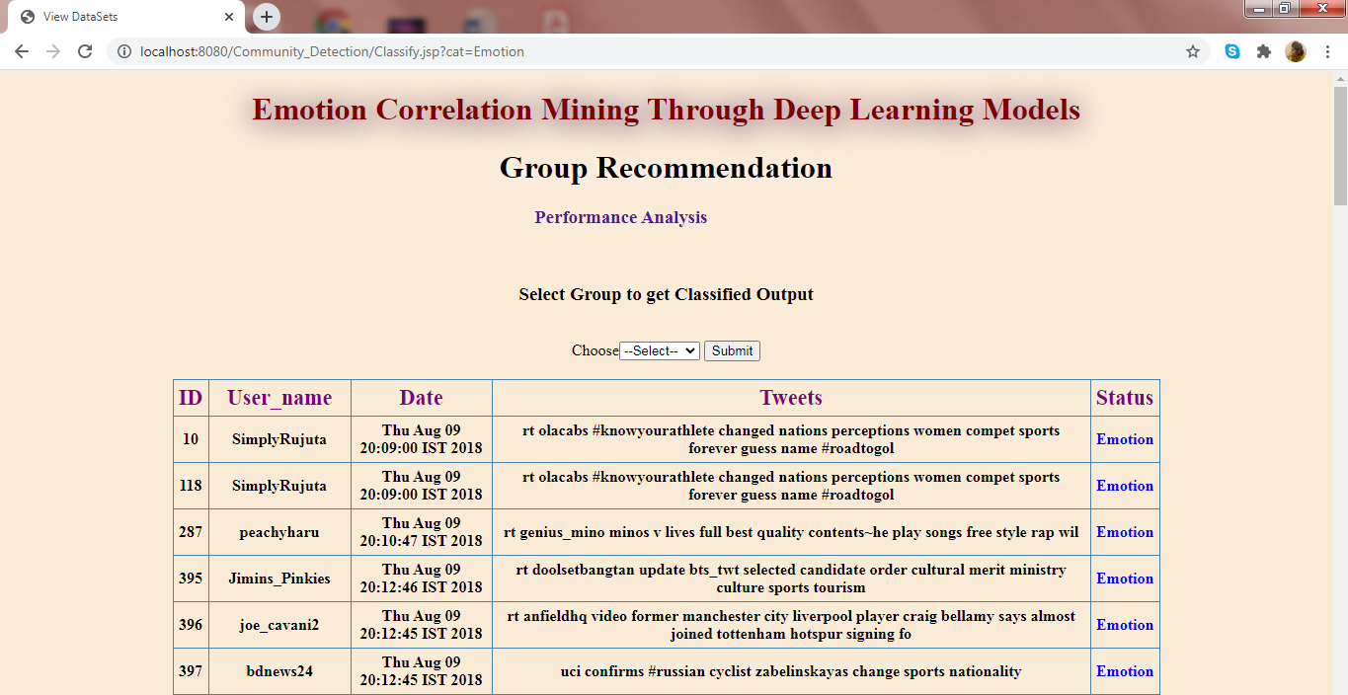
Performance Analysis

- CONCLUSION

The project Emotion Correlation Mining through Deep Learning Models on Natural Language Text mines the correlation of emotions based on the emotion recognition result of state-of-the- art deep learning models. The errors caused by the dataset and models are cut down by designing three kinds of features and two deep neural-network models. The emotion correlation is mined through an emotion confusion law, which is undirected, and an emotion evolution law, which is directed.

- REFERENCES
- A. Ali, S. Ghaderi, and S. Sohrabkhani. Forecasting electrical consumptionby integration of neural network, time series and anova. Applied Mathematics and Computation, 186(2):1753–1761,2007.

- C. Alzate, M. Espinoza, M. De, and J. Suykens. Identifying customer profiles in power load time series using spectral clustering. In Proceedings of International Conference on Artificial Neural Networks, pages 315–324. Springer,2009.

- C. Alzate and M. Sinn. Improved electricity load forecasting via kernel spectral clustering of smart meters. In Proceedings of IEEE 13th International Conference on Data Mining, pages 943–948. IEEE,2013

- X. Wang, X. Luo, and J. Chen, “Social sentiment detection of event via microblog,” in Proc. IEEE Int. Conf. Comput. Sci. Eng., 2013, pp.1051–1058.

- C. Strapparava and A. Valitutti, “WordNet affect: An affective extension of WordNet,” in Proc. LREC, vol. 4, 2004, p. 40.

- J. Staiano and M. Guerini, “DepecheMood: A lexicon for emotion analysis from crowd-annotated news,” 2014. [Online]. Available:arXiv:1405.1605.

- F. Strack and R. Deutsch, “The duality of everyday life: Dual-process and dual system models in social psychology,” in APA Handbook of Personality and Social Psychology, vol. 1. Washington, DC, USA: Amer. Psychol. Assoc., 2015, pp. 891–927.

- G. Badaro, H. Jundi, H. M. Hajj, and W. El-Hajj, “EmowordNet: Automatic expansion of emotion lexicon using English WordNet,” in Proc. 7th Joint Conf. Lexical Comput. Semantics, 2018, pp.86–93

